**Part I.**

Draw a cat on the left side of your paper and a refrigerator on the right. Make a T-chart and list their similarities and differences.

biotic tree soil abiotic rain living leaf without physical plants biotic ecosystems abiotic adapted non-living without life butterfly life factors control sunlight grow

**Part II.**

In each of the world’s ___________________ there are two things that influence the lives of the _______________ that live there: ______________ and ________________ factors. The prefix a- is Greek for __________________ and –bios is the Greek word for _________________. The term abiotic literally means ______________________.

Abiotic factors refer to the _________________ things in a plant’s ___________ environment. Sunlight, _________, wind, __________, and temperature are all _________ factors. __________ factors are the _____________ organisms in a plants environment. A _______________ pollinating a flower, a Monarch caterpillar munching on a ________, and a Robin’s nest in a ________are biotic factors.

Plants are ______________ to the biotic and abiotic ___________ in the environment in which they grow. In the conservatory, scientists can ______________ those factors. Factors such as water, _______________, temperature, and soil. By having a conservatory, we are able to grow plants that would not naturally ___________in this area.

**Part III.**

1. _____________ the study of the ___________________ between biotic and abiotic factors in _________________.
2. ______________ includes all ______________ and ______________ factors in one particular environment.

Definition Use the word in a sentence.

Give Examples Write a test question.

Definition Use the word in a sentence.

Give Examples

1. TRUE or FALSE: Ecosystems have clear boundaries due to biotic and abiotic changes.
2. TRUE or FALSE: Ecosystems can change daily as things move from one ecosystem to another.
3. Biotic changes that cause things to move from one ecosystem to another: _______________________  
   ____________________________________________________________________________________
4. Abiotic changes that cause things to move from one ecosystem to another: ______________________  
   ____________________________________________________________________________________

**Part IV.** Complete the Venn diagram and determine which are examples of abiotic and biotic.

Abiotic Biotic

Whale Clock Water Fish Paper Glass Aluminum Wooden Ruler Sand Clouds Corpse Snail Steak Pork Chops Salad Bread Plant Hair Finger Nails Pipe Cotton Fabric Wool Gold Plastic Grapes Air

1. Biotic factors ____________________ with each other in ________________ ways, such as _________________________, mutualism, and __________________________.
2. Biotic factors also interact with _________________________________ in the ecosystem. Biotic factors are __________________ upon water, __________________, temperature, and ___________.

Part V. Using the picture, make a list of all the factors that are abiotic and biotic.

http://www.glogster.com/media/2/6/8/75/6087598.jpg

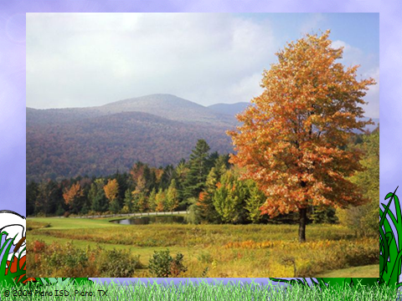

Abiotic Biotic

____________ ____________

____________ ____________

____________ ____________

____________ ____________

____________ ____________

____________ ____________

____________ ____________

____________ ____________

____________ ____________

**Part VI.** The following list of words needs that need to be placed into the category “biotic” or “abiotic” Place an “A” on the line if the word describes an abiotic factor and a “B” on the line if the word describes a biotic factor.

_______ Whale ______ Clouds _______ Fish

_______ Clock _______ Gold _______ Grapes

_______ Water _______ Plastic _______ Air

_______ Paper _______ Aluminum _______ Glass

_______ Wooden Ruler _______ Finger Nails _______ Sand

_______ Corpse _______ Snail _______ Salad

_______ Bread _______ Plant _______ Hair

_______ Pipe _______ Cotton Fabric _______ Wool