AP Environmental Science
Biodiversity Hotspots Webquest Name: _________________________________

Go to the Conservation International website http://www.biodiversityhotspots.org

I. Double click on the map on the home page of the website to open the link and find the locations of the 12 hotspots listed below. Mark them by number on the world map below.

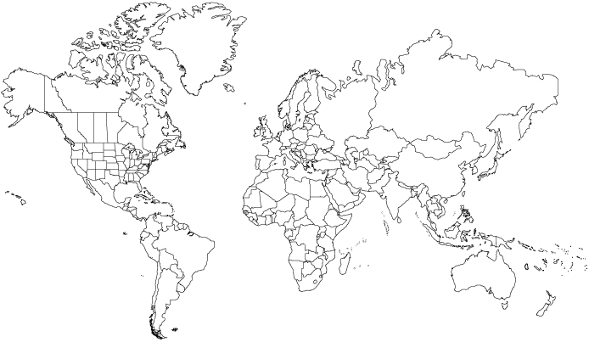

North and Central America  1. California Floristic Province  2. Caribbean Islands  3. Mesoamerica  South America  4. Cerrado  5. Tropical Andes | Europe and Central Asia  6. Mediterranean Basin  Africa  7. Coastal Forests of Eastern Africa  8. Guinean Forests of West Africa  9. Madagascar and the Indian Ocean Islands | Asia-Pacific  10. Himalaya  11. Philippines  12. Southwest Australia

II. Go to “Hotspots Science”, then choose “Hotspots Defined” from the menu on the left and answer these questions:
1. Who first coined the term “hotspots” with reference to biodiversity? When?
2. What are the two criteria that an area must meet in order to qualify as a hotspot?

III. Go to “Hotspots in Peril.”
1. List five reasons that hotspots are in peril.
2. What is the IUCN and what is the name of the list it compiles of the conservation status of species worldwide?
3. Is there a relationship between hotspots and population density of humans? Between hotspots and violence/war?

IV. Go to “Conservation Response.”
1. We define conservation outcomes at three scales of ecological organization. List them.
2. Name four species-specific threats.
3. What are three conservation responses to species-specific threats?
4. What is the biggest threat to species? (It is not species-specific.)
5. What should be the “primary response to the biodiversity crisis”?
6. How much might conservation efforts cost per year per hotspot?

V. Go to “Hotspots by Region” and read the overview for the following hotspots. Complete this chart.

Name of hotspot | Characteristics of region | Examples of animals | Examples of plants | Major threats
California Floristic Province
Caribbean Islands

Mesoamerica

Cerrado

Tropical Andes

Mediterranean Basin

Coastal Forests of Eastern Africa
Guinean Forests of West Africa
Madagascar and the Indian Ocean Islands
Himalaya

Philippines

Southwest Australia

