Dirt! The Movie

"Floods, drought, climate change, even war are all directly related to the way we are treating dirt."
- Why is dirt considered living?

- Explain how a small “lens” of soil leftover from the glaciers can result in a large old growth forest.

- Explain how the fungus mycelium makes dirt in a forest.

- What happened in the back of Clyde’s pickup truck while he was in the hospital?

- Explain the statement “I just had a sip of dinosaur pee” made by Andy Lipkis.

- How are animals like cows essential to the formation of dirt?

- Why does the wine expert taste and smell the dirt of the vineyards he is visiting?

- Give three examples of practical applications of the mud/dung mixtures.

- Practices such as strip mining and mountaintop removal are in pursuit of what resource?

- What happens to the heavy metals that are exposed by strip mining?

- Los Angeles is mostly covered in concrete and pavement. What happens to the water that falls on the city?

- Explain the relationship between dirt, desertification, and conflict.

- How do monocultures relate to the Dust Bowl of the 1930s?

- Why does the use of pesticides and herbicides become necessary with monocultures?

- How does the use of nitrogen fertilizers result in dead zones in bodies of water?

- What eventually happens to forest that is cut and burned?

- What is the cause of the unusually high rate of suicide of Indian farmers?

- What did the Haitians in the slum use as a remedy for hunger?

- If the agroecology methods used successfully in Burkina Faso were duplicated in Ethiopia, how productive could the country be?

- How does the root system of an annual plant such as wheat compare to the root system of a perennial plant?

- The picture below shows the root length of Kentucky Bluegrass (first on the left) followed by several examples of wild prairie plants. How might soil be more at risk when wild plants are replaced by domesticated ones like the grass?

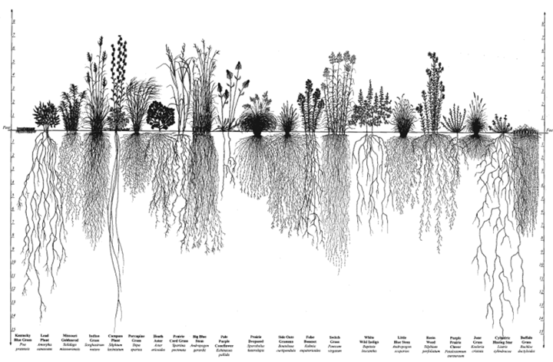

- Give two benefits of planting a “green roof”.

- Compare the types of landscapes children in urban settings use to play with those found in the rural villages of India.

- How long did it take to compost the liquid fish waste into usable soil?

- What are possible applications of the microbial fuel cells?

- The movie ends with examples of how working with the soil of the Earth can change someone’s life. Describe one of these examples.

