APES Unit 1 Earth Systems Name: ________________________________ Block: _____

Lab: Edible Soil Horizons, Climate Comparison
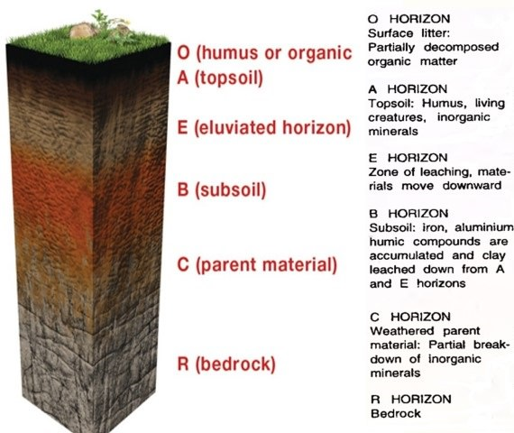
SAFETY: No food on the lab tables or on lab equipment. You may only eat food items if your teacher explicitly says it is okay. Please notify your teacher of any food allergies NOW.

Materials:
- Graham cracker (representing R-layer parent bedrock and C-layer weathered parent material)
- Vanilla pudding (representing B-layer subsoil)
- Chocolate pudding (representing A-layer topsoil)
- Gummy worm (representing a worm, duh)
- Chocolate sprinkles (representing O-layer organic litter)
- Small clear plastic cup and spoon

Directions:
- Complete the pre-lab questions below. If you have any questions, ask your teacher.
- As a group, use the food materials provided to create an edible soil profile that correctly matches each of the climate types listed. Use the five labeled diagrams to help you create your profiles.
- Show your teacher all 5 completed profiles.
- Complete the observations/questions associated with each soil profile, and complete the post-lab questions.

Pre-lab questions:
- Name and explain the two types of weathering

- What 5 factors determine soil type?

- Define bedrock. What type(s) of rocks can bedrock be made of?

- If a graham cracker will be used for the R-layer bedrock and the C-layer weathered bedrock, how will you distinguish these 2 layers?

- Define leaching.

- Define humus. Which layer(s) contain humus?

Temperate Deciduous Forest Biome | Draw and label your edible profile: | - What is a deciduous forest?  - Arid or humid climate?  - Cold, warm, or seasonal climate?  - What type of weathering is most prominent in a deciduous forest? Why?
Coniferous Forest Biome | Draw and label your edible profile: | - What is a coniferous forest?  - Arid or humid climate?  - Cold, warm, or seasonal climate?  - What type of weathering is most prominent in a coniferous forest? Why?
Grassland Biome | Draw and label your edible profile: | - What is a grassland?  - Arid or humid climate?  - Cold, warm, or seasonal climate?  - How would you describe the quality of grassland soil? Nutrient rich or nutrient poor? Thick or thin? Why?
Tropical Rainforest Biome | Draw and label your edible profile: | - What is a tropical rainforest?  - Arid or humid climate?  - Cold, warm, or seasonal climate?  - How would you describe the quality of tropical rainforest soil? Nutrient rich or nutrient poor? Thick or thin? Why?
Desert Biome | Draw and label your edible profile: | - What is a desert?  - Arid or humid climate?  - Cold, warm, or seasonal climate?  - What type of weathering is most prominent in a desert? Why?

Post-lab questions:
- What influence does the parent bedrock have on the other horizons?

- Why is the B horizon lighter in color than the A or O horizons?

- Which layer is leached? Where do the leached materials go?

- Before doing this lab were you aware that tropical rainforests have very thin soil? _________ Why is there such thin soil beneath such lush and dense vegetation?

