Names of Group Members: _________________________________________________
7th Grade Science Oil Lab Demo
There are 3 sections to this final and you will rotate between stations in order to complete these tasks. Please go to the station you are assigned to first, beginning with that section of this packet.
Station 1: Oil Spill Clean-up
In the following part of the lab, you will model an oil spill and test materials for cleaning up the spill. This experiment will help you understand why it is such a difficult task. All of the tools you will need are laid out at the station, please read through the materials list to familiarize yourself.
Materials:
one baking dish - water - blue food coloring - vegetable oil - pure cocoa powder - teaspoon -
stir rods - beaker - 1 squirt of liquid dishwashing detergent -
Procedure:
Begin by preparing your fresh water and crude oil.
1. To prepare the fresh water:
- Fill baking dish with cold tap water to within 1 cm of rim.
- Add 5-6 drops of food dye.
- Mix dye and water with a stirring rod.
- Let solution settle.
- 2. To simulate crude oil:
- Place 3 tbsp. of vegetable oil in beaker.
- Add 2 tbsp. of cocoa powder.
- Mix cocoa powder and oil thoroughly with a stir rod.
3. To contaminate fresh water:
- Very slowly pour simulated crude oil from a height of 1 cm onto the top of the fresh water dish. If you pour the oil too quickly, the experiment won't work - start over!
Record your observations. What happened to the oil when you dropped it on the fresh water/ocean?

Station 2: Data Analysis (do for homework)
In this section, you will be examining data about the effects of oil spills. This is real data collected after the Exxon Valdez spill in 1989. You will answer questions about the data and demonstrate your graphing ability.
There are several numbered graphs.
Graph 1 shows the average number of snails per meter on rocks near the spill site. Observe how their numbers change from year to year.
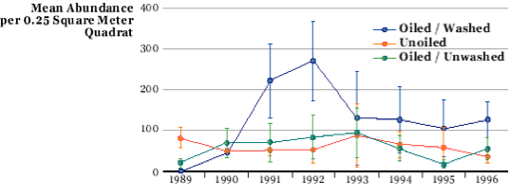

- Snails that came in contact with the oil had the lowest population in what year?
- Which population recovered most quickly, the oiled snails that were washed or the unwashed snails?
- Which group has the highest population per meter in 1996?
- Based on this data, do you think washing snail habitats after an oil spill helps the snails? Why or why not?

Now look at Graph 2. This shows how thickly a type of seaweed covered rocks near the spill site in the years after the accident. 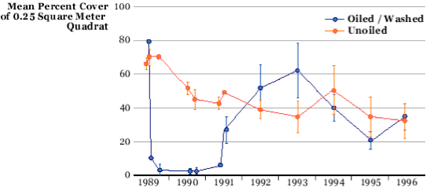

1. Based on the data you have, estimate the percentage of the rock surface that was covered with rockweed right before the spill.
2. In what year did the oiled and washed population of rockweed appear closest to its levels before the spill?
Do you think the rockweed near the spill had recovered by 1996? Why or why not?

Many other organisms were probably affected as well. The Exxon Valdez spill appears to have had an impact on the salmon fishing industry as well. Create a bar graph on the following page for the number (in millions) of pink salmon harvested each year after the spill. Be sure to label your axis.
Year | Pink Salmon Harvest (Millions of Fish)
1990 | 43
1991 | 36
1992 | 8
1993 | 3
1994 | 37
1995 | 15
1996 | 25
1997 | 25

Station 3: Cleaning Oiled Feathers
In this experiment, you'll look at the way oil affects bird feathers and try out different cleanup methods to find out which works best.
Materials
- 3 Clean, dry feathers
- Three bowls or basins
- Vegetable oil
- Dish-washing detergent
- Hot and cold water
Prediction: Write a prediction about what happens to birds and their feathers when they land on an oil slick. How are they affected?

Procedure
1. Choose some feathers from the materials at your station, then try to answer the following questions:
  - What kinds of water birds can you think of?
  - What kinds of things do water birds do?
  - What do feathers do for water birds?
2. At your station is a container with vegetable oil and water in it. Dip your feathers in the oil to imitate what happens when a bird lands on an oil slick.
- Take a look at the feathers now and write down your observations. What happened to the feathers?

- Based on what you saw; how do you think this might affect a water bird wearing these feathers?

- Now try three methods of cleaning feathers. There are 3 washing stations set up. Whatever washing technique you choose, use the same methods at each station.
  - Cold water washing: try washing some of the oiled feathers in cold water. Write down your observations.
  - Hot water washing: try washing some of the oiled feathers in hot water. Write down your observations.
  - Washing with detergent: try washing some of the oiled feathers in the warm soapy water. Write down your observations.

Conclusion:
Now write a conclusion that discusses how oil spills affect birds and what the best method to clean the birds would be.

