CHAPTER 14 REVIEW- TOXICOLOGY
** List and give examples of the four types of environmental hazards.
- ___________________________________________________________________________
- ___________________________________________________________________________
- ___________________________________________________________________________
- ___________________________________________________________________________

Toxicant | Human Health Effects | Examples | Where Found?

** Which category of toxicant shows effects in very small doses? Explain why this is the case. ________________________________________________________________________________________________________________________________________________________________

- Describe synergistic effects and how that affects level of harm. ________________________
___________________________________________________________________________

- How does the persistence time of a toxicant determine its level of harm? Describe and give examples of toxicants with long vs. short persistence times.

- Describe how the following factors can cause a toxicant’s level of harm to be different from one individual to the next.
  - Age: _________________________________________________________________
  - Sex: _________________________________________________________________
  - Weight: _______________________________________________________________
  - Type of Exposure:
    - Acute: __________________________________________________________
    - Chronic: _________________________________________________________
* Which type of exposure is more common? ___________________
* Which type of exposure is easier to detect and why? _______________________
_________________________________________________________________
Chemical Toxicants
 | Type of Toxicant | Where Found? | Human Health Effects
PBDE
BPA
Thalidomide
Lead
DDT
Radon
Asbestos
Atrazine
Mercury
PCB
Modes of Travel
- Describe the 3 ways in which toxicants can travel and spread.
  - ______________________________________________________________________
  - ______________________________________________________________________
  - ______________________________________________________________________

- Why are aquatic animals good indicators of pollution? _______________________________
___________________________________________________________________________

- Name an unexpected place on Earth in which pesticides have been found. Why were they found here? ________________________________________________________________

- Compare and contrast biomagnification and bioaccumulation.
  - Biomagnification: _______________________________________________________
  - Bioaccumulation: _______________________________________________________

- Which organisms have been shown to have high concentrations of toxicants? What does that demonstrate? _______________________________________________________________

Important People
** Describe the role of each person in bringing awareness to harms associated with environmental toxins.
- Rachel Carson: ___________________________________________________________
________________________________________________________________________________________________________________________________________________
- Theo Colburn: ____________________________________________________________
________________________________________________________________________________________________________________________________________________
- Louis Guillette: ___________________________________________________________
________________________________________________________________________________________________________________________________________________
- Tyrone Hayes: ____________________________________________________________
________________________________________________________________________________________________________________________________________________
Measuring Toxicity
 | What is it? | Pros | Cons
Case Study
Epidemiological Study
Manipulative Research
(Animal Models)

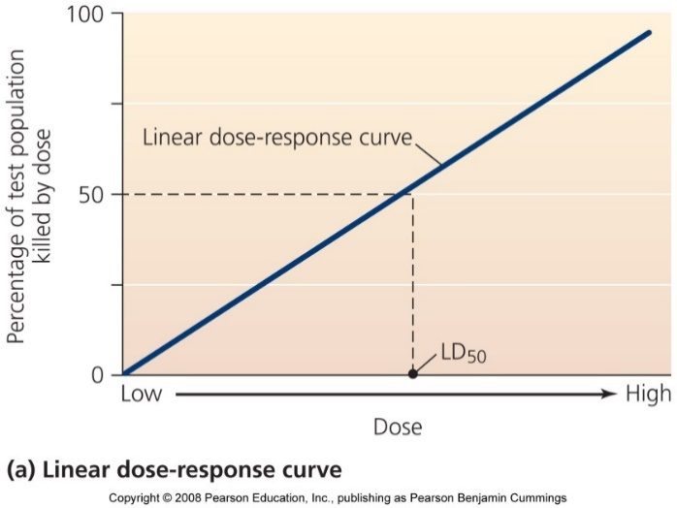
** What does the linear dose-response curve show? ___________________________________________________________________________________________________________________________
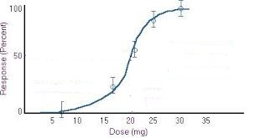
** What does the dose-response curve (left) show? ___________________________________________________________________________________________________________________________
** What is the LD₅₀? __________________
** What is the threshold? _______________
** Label both the LD₅₀ and threshold on the graph.

** How is LD₅₀ different from ED₅₀? __________________________________________________
________________________________________________________________________________
Regulation
- Contrast the precautionary principle approach versus the “innocent until proven guilty” approach? Give an example of each.

What is regulated?
USDA
FDA
CDC
OSHA
FIRFA (EPA)
TSCA (EPA)

- What was the significance of the Stockholm Convention? __________________________
________________________________________________________________________________________________________________________________________________

  - What are POP’s? ____________________________________________________

  - Give examples of “the dirty dozen”. ______________________________________
___________________________________________________________________

