CHAPTER 15 REVIEW- Water
Importance of Conserving Freshwater
- Only ______% of the Earth’s water is freshwater. Most of that is in __________________, ice caps, and in underground _________________, which means it is not readily available. That also means _______% is available for human use.

- List 3 reasons why water is important for the effective functioning of Earth’s systems.
  - ______________________________________________________________________
  - ______________________________________________________________________
  - ______________________________________________________________________
Rivers and Streams
- Flow of water: Rain _________________ __________________ ________________
- Tributary vs. Watershed
- Shapes landforms
  - Oxbow lake: ___________________________________________________________
  - Flat valleys: ___________________________________________________________
  - Floodplains: ___________________________________________________________
    - Soil is ____________________
    - Biodiversity is _________________________
Wetlands
- Areas that combine freshwater with __________________________
- Soil is _________________________
- Biodiversity is ____________________________
- Describe some ecosystem services provided by wetlands.
  - ______________________________________________________________________
  - ______________________________________________________________________
  - ______________________________________________________________________
- How have humans altered wetlands? What are the ecosystem effects of this?
Type of Wetland | Characteristics

Lakes and Ponds
Zone | Location | Characteristics | Organisms

- Oligotrophic vs. Eutrophic
- How can lakes change from oligotrophic to eutrophic (and vice versa)?

Groundwater
- Groundwater makes up about ______% of the Earth’s freshwater supply, and is contained within reservoirs known as __________________.

- Label the following aquifer (zone of saturation, zone of aeration, water table, recharge zone, confined, unconfined)
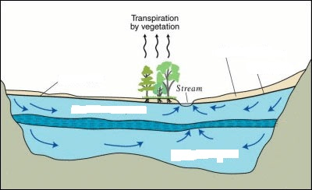

- Which type of aquifer is easily recharged? ___________________________________
- How does groundwater become surface water? ____________________________________
- How does surface water become groundwater? ____________________________________
- What is one initial indication of a falling water table in an ecosystem? ___________________
- What are two other effects of falling water table?
  - ______________________________________________________________________
  - ______________________________________________________________________

Water Use
- Label the graph (include %) to show how water is used in the United States.

- Consumptive Use: ___________________________________________________________
  - Ex: ____________________________________________________
- Non-consumptive Use: ________________________________________________________
  - Ex: ____________________________________________________

Diversion of Water
- Water is diverted to suit our needs by _____________, or any obstruction to block the flow water so it can be stored in a reservoir.
Benefits | Drawbacks

** Removal of dams has restored ___________________ habitats.
- Describe/discuss how human activity impacted the ecology surrounding the Colorado River and Aral Sea.

Solutions to Freshwater Depletion
Desalination | Agricultural | Industrial | Residential

** What is gray water? How can it be used to conserve water? ______________________________
________________________________________________________________________________________________________________________________________________________________

Freshwater Pollution
Type | Causes | Effects on Organisms/Humans | Solutions

- Point-source vs. Non-point-source (with examples)

Wastewater Treatment
- Septic system vs. municipal sewer system

WATER QUALITY TESTING
Test | What is measured? | Implications of Stream/Water Quality
Physical Indicators
Chemical Indicators
Biotic Indicators

